**SENTIMENT ANALYSIS OF STUDENTS AND LECTURERS DURING ASUU (ACADEMIC STAFF UNION OF UNIVERSITIES) STRIKE.**

**BY**

**NDIFREKE MKPANAM EKANEM**

**KASU/18/CSC/1017**

**A PROJECT SUBMITTED TO THE DEPARTMENT OF COMPUTER SCIENCE KADUNA STATE UNIVERSITY (KASU) KADUNA – NIGERIA IN PARTIAL FULLFILMENT OF THE REQUIREMENTS FOR THE AWARD OF THE DEGREE OF BACHELOR OF SCIENCE (B.S.c) IN COMPUTER SCIENCE**

**PROJECT SUPERVISOR**

**MAL. Falalu Ibrahim Lawan**

# **DECLARATION**

**I Ndifreke Mkpanam Ekanem,** hereby declare that this project titled **SENTIMENT ANALYSIS OF STUDENTS AND LECTURERS DURING ASUU (ACADEMIC STAFF UNION OF UNIVERSITIES) STRIKE** has been carried out by me under the supervision **MAL. Falalu Ibrahim Lawan**. It has not been presented for award of any degree in any Institution. All sources of information are specifically acknowledged by means of reference.

**_______________________**

**Ndifreke Mkpanam Ekanem**

**_______________________**

**Date**

# **CERTIFICATION**

This project titled SENTIMENT ANALYSIS OF STUDENTS AND LECTURERS DURING ASUU (ACADEMIC STAFF UNION OF UNIVERSITIES) STRIKE by NDIFREKE MKPANAM EKANEM with matriculation number KASU/18/CSC/1017 meets the requirements governing the award of the degree of Bachelor of Science in Computer Science and is approved for its contribution to knowledge and literary presentation.

**________________________ ____________________**

**Mal. Falalu Ibrahim Lawan Date**

**(Project Supervisor)**

**________________________ ____________________**

**Mr. Shamsudeen Umaru Date**

**(Project Coordinator)**

**________________________ ____________________**

**Dr. Rabi Mustapha Date**

**(Head of Department)**

# **DEDICATION**

I dedicate this work to the Almighty, whose unwavering grace has led me this far. My parents, whose selfless love and selfless sacrifices have inspired me. My profound gratitude to my amazing lecturers, whose knowledge and support have enabled me to comprehend and complete this project.

# **ACKNOWLEDGMENT**

I will always be indebted to the Almighty, whose boundless grace and wisdom have given me courage and inspiration.

I would like to thank Mal. Falalu Ibrahim Lawan, my project supervisor, from the bottom of my heart.

Our sincere gratitude goes out to Professor Rabi Mustapha, the head of Kaduna State University's computer science department, for creating a culture of academic success and for providing the tools needed for this project.

I am appreciative of all the support and encouragement this project received from a number of eminent academic and non-academic members of the university staff.

I owe my family a great deal of gratitude because they have been my rock solid foundation of love, support, and understanding.

To my friends: because of your friendship, this trip will always be remembered because you helped me along the way, laughed with me, and supported me when things got tough.

# **ABSTRACT**

# This study uses sentiment analysis to look at how professors and students felt about the Academic Staff Union of Universities (ASUU) strikes in Nigeria. The research uses natural language processing methods and machine learning algorithms to create a system that can recognize and distinguish between distinct emotions expressed in text, particularly on microblogging platforms like Twitter. The research takes into account the difficulties presented by sarcasm, emoticons, and casual communication styles in order to recognize the dynamic nature of sentiment in the digital sphere.

# The study focuses on the time frame around the February 14, 2022, start of the statewide ASUU strike. Through the examination of past tweets including pertinent hashtags like #ASUU, the research seeks to uncover the range of viewpoints and affective responses expressed by users during this pivotal period. The study's focus is on how ASUU strikes affect instructors' and students' academic performance while also considering the interruptions, annoyances, and unforeseen effects on society as a whole.

# Developing machine learning algorithms to identify emotions, gathering and preprocessing a large dataset of students' and instructors' expressed emotions, and investigating brain-stimulating alternatives during strikes are some of the specific goals. Notwithstanding the fact that sentiment changes over time and that training data may be biased, the study acknowledges several limitations.

# The study's contribution to the development of sentiment analysis and natural language processing methods is what makes it significant. It is anticipated that the proposed emotion recognition method would contribute to the body of academic research on sentiment analysis and its applications by offering insightful information about the intricate interactions between emotions during ASUU strikes.

# **TABLE OF CONTENTS**

**DECLARATION** ii

**CERTIFICATION** iii

**DEDICATION** iv

**ACKNOWLEDGMENT** v

**ABSTRACT** vi

**TABLE OF CONTENTS** vii

**LIST OF FIGURES** xi

**CHAPTER ONE** 1

**INTRODUCTION** 1

**1.1 Overview of Sentiment Analysis** 1

**1.2 Background to the Study** 1

**1.3 Problem Statement** 2

**1.4 Aim and Objectives** 2

**1.5 Scope and Limitations** 2

**1.6 Significance of Study** 3

**CHAPTER TWO** 4

**LITERATURE REVIEW** 4

**2.1 Introduction** 4

**2.2 X (formerly twitter) and opinion mining** 4

**2.3 Educational Contexts and Sentiment Analysis** 5

**2.4 ASUU Strikes: Historical Context** 6

**2.5 Related Studies** 7

**CHAPTER THREE** 9

**RESEARCH METHODOLOGY** 9

**3.1 Data source and overview** 9

**3.1.1 Model objective** 9

**3.2 Data Pre-Processing** 9

**3.2.1 Data Collection**. 9

**3.2.2 Feature Extraction:** 9

**3.3 Label Encoding: Giving Categories Numerical Values** 9

**3.4 Standardization and Scaling** 10

**3.4.1 Equitable Participation** 10

**3.4.2 Placing Features on a Common Scale** 10

**3.5 Classification Techniques** 11

**3.5.1 The Idea behind SVM** 11

**3.5.1.1 SVM Algorithm** 11

**3.5.1.2 The drawbacks of SVM** 11

**3.5.2 Transformer-Based Model's Concept (Pre-trained DistilBERT)** 12

**3.5.2.1Transformer-Based Model (DistilBERT Algorithm with Pre-training)** 12

**3.5.2.2 Transformer-Based Model's (Pre-trained DistilBERT) Drawbacks** 13

**3.5.3 Rule-Based Sentiment Analysis's Concept (AFINN Lexicon)** 13

**3.5.3.1 Algorithm for Rule-Based Sentiment Analysis (AFINN Lexicon)** 14

**3.5.3.2 Rule-Based Sentiment Analysis's Drawbacks (AFINN Lexicon)** 15

**3.5.4 The Concept of VADER** 15

**3.5.4.1 VADER Algorithms** 16

**3.5.4.1 Drawbacks of VADER** 16

**CHAPTER FOUR** 18

**DATA ANALYSIS AND DISCUSSION OF RESULTS** 18

**4.1 Data Presentation and Preprocessing** 18

**4.1.1 Data Collection** 18

**4.1.2 Data Preprocessing** 19

**4.1.3 Challenges Faced** 20

**4.1.4 Pre-processing and Cleaning Results** 21

**4.2 Model Training and Evaluation Results** 22

**4.2.1 Data Preparation** 22

**4.2.2 Sentiment Analysis** 22

**4.2.2.1 Twitter Users' Views on the ASUU Walkout** 22

**4.2.3 Model Training/ Topic Modelling** 24

**4.2.3.1 Support Vector Machine (SVM) Model** 24

**4.2.3.2 Vectorization with TF-IDF** 24

**4.2.3.3 SVM Framework** 24

**4.2.4 Hyperparameter Tuning** 24

**4.2.5 Model Evaluation** 26

**4.3 Performance Analysis and Comparison** 27

**4.3.1 Assessment of Models for Sentiment Analysis** 27

**4.3.2 Analysis of Accuracy** 27

**4.3.3 Sentiment Class-Dependent Precision** 27

**4.3.4 Factors Affecting Precision** 28

**4.3.5 Consequences for Emotion Analysis** 28

**4.3.6 Suggestions for Further Research** 28

**4.4 Model Comparison** 28

**4.4.1 Heat map for Classification Report:** 29

**4.4.2 Accuracy of Sentiment Analysis via Correlation Analysis** 30

**4.4.3 Investigated Data Characteristics** 30

**4.4.4 Initial Results** 30

**4.5 Discussion and Interpretation of Sentiment Analysis Results** 30

**4.5.1 Topic Modelling Results** 31

**4.5.2 Valuable Takeaways** 32

**4.5.3 Consequences** 32

**4.5.3 Importance of Emotional Analysis** 33

**4.6 Alternatives to School During The ASUU Strike** 33

**4.7 Limitations and Future Work** 34

**4.7.1 Particular Restrictions:** 34

**4.7.2 Possible Enhancements:** 34

**CHAPTER FIVE** 36

**SUMMARY, CONCLUSIONS AND RECOMMENDATIONS** 36

**5.1 Summary** 36

**5.2 Limitations of the Research** 36

**5.3 Suggestions for Improvement** 36

**5.4 Additional Research Subjects** 37

References 38

**LIST OF FIGURES**

**Figure 1** **Support Vector Model** 22

**Figure 2 Transformer-Based Model's Concept (Pre-trained DistilBERT)** 24

**Figure 3 AFINN Lexicon** 26

**Figure 4 Vadar Algorithms** 28

**Figure 5 Stages of the Study** 30

**Figure 6 Screenshot of some Extracted tweets** 30

**Figure 7 Text Normalization and Tokenization** 31

**Figure 8 Bi-Grams** 32

**Figure 9 Table of top 10 Occurring Words** 33

**Figure 10 Word Cloud of Top 30 Words** 34

**Figure 11 Distribution of sentiments before splitting** 35

**Figure 12 Distribution of sentiments in Testing Set** 36

**Figure 13 GridSearchCV** 38

**Figure 14 Precision-Recall Curve** 39

**Figure 15 Confusion Matric for the Best SVM Model** 43

**Figure 16 Featured Tweets and Sentiments** 45

**Figure 17 LDA Topics and Keywords** 46

# **CHAPTER ONE**

# **INTRODUCTION**

# **1.1 Overview of Sentiment Analysis**

# Emotions are defined as strong feelings that an individual feels toward something or someone in reaction to internal or external events that hold special meaning for them. These days, the internet is a vital tool for people to express their thoughts, feelings, and emotions. (Padgalwar, 2019). The project's goal is to create and hone machine learning models for sentiment analysis and emotion detection in order to identify the feelings of instructors and students during the ASUU Strike.

# Sentiment analysis, sometimes referred to as emotion detection, is a branch of natural language processing (NLP) that works with textual data to extract and interpret sentiments. In order to determine the emotional tone or attitude conveyed in a text, computational techniques like machine learning algorithms are used in this process. (Cambria et al., 2020).

# **1.2 Background to the Study**

Recent research has highlighted the growing significance of emotion detection and recognition in Natural Language Processing (NLP), with ERDENEBILEG BATBAATAR (2019) highlighting its relevance in a range of applications. This acknowledgement is especially relevant to modern written expressions, which can be found in a variety of formats on social media sites, microblogs, news articles, and customer reviews. These media often contain short-text content, which has emerged as a useful tool for text mining and provides a way to investigate and comprehend a variety of topics, including the complex world of emotions.

ASUU's (Academic Staff Union of Universities) nationwide walkout that began on February 14, 2022, in an attempt to carry out a long-standing 2009 agreement with the government, set off a chain reaction of conversations and expressions on social media. Being a major player in this space, Twitter developed into a lively forum where people discussed, debated, and shared their opinions using trending hashtags like #ASUU and #ASUUStrike. According to McGregor (2019), this digital discourse facilitated the examination of users' thoughts and feelings in real time, adding to a digital mosaic of viewpoints.

ASUU strikes, which have been a recurrent occurrence in Nigeria for the past five years, have interfered with both students' and instructors' academic careers. Taking advantage of Twitter's widespread use, scholars such as Muhammad (2022) have utilized sentiment analysis and topic modeling methodologies to explore the varied viewpoints and affective reactions of users amidst these strikes. This analytical method highlights the intricate interaction of emotions during such events and offers a nuanced understanding of the sentiments circulating within the digital space.

In keeping with this story, Njoku's (2022) study explores how ASUU strikes have affected students' academic goals in public university settings. The results reveal disruptions in the classroom, erratic class schedules, and students feeling disheartened and unmotivated to pursue their academic goals.

## Some students shift their attention away from their studies and toward other activities in the face of these challenges. Unfortunately, this inactivity can result in engagement in violent crimes such as rape, kidnapping, and robbery, which has a substantial negative influence on social cohesion and stability in Nigeria. But more research is needed to determine just how much ASUU strikes affect students' academic performance. With an eye toward the intricate relationship between academic disruptions, frustration, and the unintended consequences on societal well-being, this research attempts to precisely assess the emotional impact of these strikes on both students and lecturers.

# **1.3 Problem Statement**

The Academic Staff Union of Universities' (ASUU) ongoing strikes have inadvertently hampered the academic advancement of Nigerian professors and students. These interruptions present a variety of difficulties for them in their academic pursuits, including extended study sessions, subpar performance on tests, and consequent implications on their final grades. Long-term absences from school disrupt both students' and instructors' academic routines, and instructors may become disengaged from current practices and face financial difficulties as a result of unpaid salaries. Pupils who live in homes that don't encourage effective learning frequently become frustrated because they don't know when classes will resume.

Some students shift their attention away from their studies and toward other activities in the face of these challenges. Unfortunately, this inactivity can result in engagement in violent crimes such as rape, kidnapping, and robbery, which has a substantial negative influence on social cohesion and stability in Nigeria. But more research is needed to determine just how much ASUU strikes affect students' academic performance. This study attempts to precisely evaluate the affective toll that these strikes have on students and instructors, acknowledging the intricate relationship between academic disruptions, annoyance, and the inadvertent effects on the general welfare of society.

# **1.4 Aim and Objectives**

Nigeria’s university education goes through incessant strikes by the Academic Staff Union of Universities (ASUU). This strike has led to shared emotion on micro-blogging sites like Twitter. This study analyzed selected historical tweets from the “ASUU” to understand citizens’ opinions.

**The specific objectives are as follows:**

* **Objective** **1**: To develop machine learning algorithms or techniques that can effectively distinguish and detect the different types of emotions portrayed by students and lecturers.
* **Objective 2**: To collect and preprocess a comprehensive dataset where students and lecturers expressed their emotions
* **Objective** **3**: To understand the emotions portrayed and recommend meaningful alternatives to school that keep the brain active during said strikes.

# **1.5 Scope and Limitations**

The feelings that instructors and students experienced during the ASUU Strike are the focus of this project. However, because this is text-based, the project's accuracy in identifying emotions is restricted by casual communication styles, sarcasm, and emoji. Even in the event that some data is misinterpreted, the system ought to be able to produce reliable results.

**Limitations of the Study:**

1. **Bias in Data**:
   * The accuracy of emotion detection during ASUU Strikes depends on the quality and representativeness of the training data.
   * Biases in the dataset can influence the model’s understanding.
   * It’s essential to address biases to improve the system’s performance.
2. **Dynamic Nature of Sentiment**:
   * Public sentiment is dynamic and can change rapidly during ASUU Strikes.
   * This Project is not in real time.
   * Capturing emotions during a specific timeframe may not fully reflect the evolving emotional landscape.
   * Real-time insights are impacted by this temporal sensitivity.
   * Unable to accurately detect who is a student and who a lecturer is due to the dynamic nature of the dataset.

# **1.6 Significance of Study**

With enough language processing capabilities, the machine learning model will be able to identify the most common emotions expressed in written content. Furthermore, the study's creation of a machine learning-based emotion detection system can advance sentiment analysis and natural language processing methods. The results have the potential to enhance scholarly works on sentiment analysis and its uses.

# **CHAPTER TWO**

# **LITERATURE REVIEW**

# **2.1 Introduction**

Machine learning is a subfield of artificial intelligence (AI), which is the study of creating computer systems that can solve a variety of issues, including automatically identifying patterns and features in data and making decisions to make predictions. According to (Mahesh, 2019) Machine learning (ML) is the scientific study of algorithms and statistical models that computer systems use to perform a specific task without being explicitly programmed.

According to (Jagota, 2020), Sentiment analysis is the process of determining if a piece of writing is neutral, positive, or negative. Opinion mining is another term for this process, which involves determining a speaker's attitude or opinion. Researching public opinion on particular subjects is one of the most common uses of this technology. In order to interpret the emotional tone or sentiment expressed in textual data, sentiment determination entails the application of various technologies and methodologies from the field of Natural Language Processing (NLP).

There are multiple methods of sentiment analysis but this study requires the machine learning approach. According to (Pandya, 2020) In their paper, a method was proposed; the Machine Learning approach uses training data and test data, two different sets of documents, for initial classification. Text features are extracted from this involuntary classification and are then divided into supervised and unsupervised categories. Labeled training datasets are used in the supervised system; each class has distinct attributes and labels that correspond to them. (Pandya, 2020) also described the data collection process in their papers. As previously mentioned, the main goal of sentiment analysis is data collection, which is typically done through pre-existing resources and social media platforms like Facebook and Twitter. For this, a variety of sources are useful, including news articles, social networks, blogs and forums, and reviews.

# **2.2 X (formerly twitter) and opinion mining**

As stated by (Muhammad, 2022), "Social media" refers to a broad category of technologies, such as video hosting networks, blogs, networks, picture-sharing platforms, communities, microblogs, corporate social networking sites, and a"Social media" refers to a broad category of technologies that includes social networks, blogs, networks, photo-sharing platforms, communities, microblogs, corporate social networking sites, and video hosting networks. Despite being a relatively new addition to social media, microblogs have become very popular. Social networking sites such as Facebook, YouTube, and Twitter enable people to interact and exchange ideas in a variety of real-world contexts. The popularity of social networking sites has been aided by their widespread use, which allows users to interact with one another and share text, photos, and videos.

Companies utilize social media platforms as important sources of information for monitoring public opinion and conducting surveys about their products. Microblogging applications, particularly Twitter, have become highly popular and widely used platforms that provide diverse information. Twitter, a well-known microblogging service, facilitates the real-time exchange, communication, and understanding of brief and concise messages known as tweets (Muhammad, 2022).

The availability of vast amounts of data on Twitter has generated increased interest among experts in the field of sentiment analysis and opinion mining. However, cutting-edge research has primarily focused on sentiment analysis, aiming to extract and categorize data related to twitter users' perspectives on a wide range of topics, including

With significant advancements in information and communication technology, data analytics has become an essential tool for improving company operations and setting corporate objectives that align with client expectations. Opinion mining, which extends beyond the business realm, holds relevance in various fields such as government and politics. As a result, it has gained significant momentum and attracted the attention of researchers interested in its application across different domains.

As a digital environment, Twitter is essential in creating a new social structure. Twitter is a dynamic communication network with over a billion logins, millions of active users, and 500 million tweets per day. Unless the author requests to keep it private, every message on Twitter—which was initially restricted to 140 characters until October 2018 and is currently expanded to 280 characters—is visible to the public. Retweeting, mentioning other accounts, liking, and commenting on tweets are ways that users engage with the content. Additionally, Twitter's accessible Application Programming Interfaces (APIs) have made data collection simpler.

# **2.3 Educational Contexts and Sentiment Analysis**

As per Ye's 2023 study, sentiment analysis (SA) has garnered significant interest across diverse domains and has emerged as a central topic in educational research. Nevertheless, thorough literature reviews that concentrate on SA in education are conspicuously lacking. Thus, the purpose of this study is to close this gap by carrying out a comprehensive analysis of the best scientific literature on SA in the context of education. Providing insights from the reviewed papers and illuminating potential directions for future research are the objectives. The study identifies and thoroughly examines four key areas of research on SA in education. In order to increase the precision of sentiment analysis in educational settings, the first topic focuses on developing SA techniques and systems. The second topic delves into the attitudes, concerns, and level of satisfaction of the learners, offering a more nuanced understanding of their feelings. The study also emphasizes the significance of assessing teachers' effectiveness in the classroom and acknowledges the influence of emotion on the learning process (Ye, 2023). Finally, delving into the intricate connection between emotions, behavior, performance, and accomplishment offers a comprehensive viewpoint on the influence of sentiments in the educational setting.

As stated by (Omozusi Mercy Omosefe, 2023), A nation's overall progress and the comprehensive development of its citizens are greatly aided by education. Nonetheless, both students and the union members themselves have suffered as a result of the repeated strikes called by the Academic Staff Union of Universities (ASUU). In the context of sentiment analysis in education, this study intends to investigate the effects of ASUU strikes on the social and psychological health of Nigerian university students.

Lastly, exploring the complex relationship between feelings and behavior, performance, accomplishment, and behavior provides a comprehensive perspective on the impact of emotions in the classroom.

This study, which employs a descriptive survey research design, focuses on University of Lagos undergraduate students. A specially designed questionnaire was used as the research instrument, and 396 students in total were chosen at random to participate. Descriptive statistics, which include metrics like frequency, percentage, mean, and standard deviation, were used to answer the study questions.

# **2.4 ASUU Strikes: Historical Context**

(Gboyega, 2022) produced a very good history on his paper that examines the long history of strikes in Nigeria from 1999 to 2020 carried out by the Academic Staff Union of Universities (ASUU). The prolonged strikes by ASUU, which lasted for more than three years, are portrayed as attempts to protect the nation's educational system from unfavorable conditions that might harm its standing internationally.

The nationwide strikes by ASUU began in 1999 with Chief Olusegun Obasanjo's ascension to the position of Executive President. The strikes lasted for five months. Strikes that followed in 2001, 2002, and 2003 were brought on by grievances about supposedly unjust dismissals of instructors, breaches of contracts, and inadequate financing for colleges.

Over the years, ASUU continued to participate in a number of strikes, each with its own set of demands and complaints. The union's activism culminated in a series of strikes in 2005, 2006, 2007, and 2008, ranging from legal battles concerning dismissed lecturers to disagreements regarding funding and policy implementation.

A nationwide walkout occurred in 2009 and lasted for four months. ASUU voiced their displeasure with what they saw as the government's carelessness in carrying out agreements. The union called for the implementation of agreements, policy reviews, and increased funding for the education sector during more strikes in the years that followed.

ASUU called for better funding for Nigerian universities and the implementation of past agreements through strikes in 2017 and 2018. These strikes had a major effect on students all around the country and continued for several months.

During these strikes, ASUU leadership advised students to concentrate on honing their skills, but it's obvious that this has had a negative impact on the educational system. A second warning strike was declared in 2020 as a result of disputes originating from the government payroll system.

The ASUU Strike of 2022 was the longest in Nigerian history, lasting an exhausting eight months. Thanks to the court's intervention, the strike ended on October 17, 2022, having started on February 14 of that same year. This established a new record for the longest ASUU strike ever. (Aihinoria, 2022)

## An approximate estimate of 36 months is what results from adding up the total number of months that ASUU has been on strike. This amount is equivalent to about three years' worth of ASUU strikes.

## The tenacity with which ASUU pursued their demands serves as a reminder of the difficulties confronting Nigeria's educational system. It is still unclear if ASUU and the government can come to any fruitful agreements in their upcoming talks.

# **2.5 Related Studies**

The section examines the classification of sentiments and the mining of opinions using data from Twitter, with a specific focus on trends in Nigeria. The following literary works offer insights into related methodologies, which will be thoroughly examined for advancements and future recommendations.

In their study, (Erin Hea-Jin Kim, 2016) evaluated how the Ebola virus was covered on Twitter and in traditional news sources, as well as the dynamics of sentiment surrounding the topic. In comparison to traditional media, the research showed that Twitter covered the issue less thoroughly and clearly. Twitter's sentiment dynamics exhibited reduced longevity and variability. The LDA technique was utilized by the authors to model topics based on comments from social media platforms.

(Oyebode, 2019) conducted a survey to determine the public's perceptions of two well-known political candidates in Nigeria in order to assess their prospects of becoming influential figures. They used TextBlob, VADER, and VADER-EXT as sentiment analysis tools.

(Hassan Adamu, 2021) utilized the Twitter API to assess public opinion on disaster response, including the distribution of COVID-19 relief packages. They utilized the Nigerian Local English Slang-Pidgin (NLES-P) dataset to train machine learning models such as Support Vector Machines for sentiment classification.

(Panchali Guha, 2021) carried out dictionary-based sentiment analysis using R on tweets containing the hashtags #phdlife and #phdchat to gain insights into the concerns of PhD students.

(Hamsuddeen Hassan Muhammad, 2022) introduced NaijaSenti, an extensive dataset on Twitter sentiment for four major languages spoken in Nigeria: Hausa, Igbo, Nigerian-Pidgin, and Yorùbá. The dataset consisted of approximately 30,000 annotated tweets for each dialect.

(Adebayo Abayomi-Alli, 2022) Conducted an analysis on "yahoo-yahoo" tweets using various techniques including VADER, Liu Hu technique, LDA, and MDS. The findings revealed that VADER performed better than other sentiment models, while LDA and LSI produced comparable topic models.

As far as the researchers are aware, no prior research has used Twitter data for sentiment analysis on the ASUU strike. The purpose of this study is to close this gap by using sentiment analysis to identify important themes in tweets containing the term "ASUU." The study makes use of RapidMiner (RM) studio's machine learning, modeling, and data preprocessing features for data extraction and analysis. Natural language processing (NLP) features offered by RM include case transformations, text categorization, stemming, stop word removal, and other techniques for analyzing texts and identifying significant word relationships. (Nandal, 2022).

# **CHAPTER THREE**

# **RESEARCH METHODOLOGY**

# **3.1 Data source and overview**

This study uses a large dataset from the online social media platform Twitter to create a predictive model for sentiment analysis using machine learning techniques. Records of tweets made by educators, students, and other interested parties are included in the dataset. The Twitter operator for RM Search utilized English when searching for tweets, particularly those originating from Nigeria. A total of 10,000 tweets were gathered. This process took place over three days, from May 14, 2022 to May 16, 2022. The word "ASUU" was used to locate tweets about the search.

# **3.1.1 Model objective**

The model's objective is to accurately classify and identify emotions expressed by students and lecturers during these strikes.

# **3.2 Data Pre-Processing**

# **3.2.1 Data Collection**: The RM Search Twitter operator was used in the data collection process. This operator focused on English-language tweets in particular, especially those coming from Nigeria. May 14, 2022, was the start of the three-day search operation, which ended on May 16, 2022. The Academic Staff Union of Universities was the focus of the search term "ASUU," which was used to find pertinent tweets.

10,000 tweets in all were found using this search method. The data collection in the investigation forms the foundation for the analyses that come after. It offers a substantial quantity of Twitter information covering conversations, viewpoints, and feelings about ASUU over the designated time frame.

**3.2.2 Feature Extraction:** When faced with a plethora of information, many of which may be unrelated to the task at hand, data professionals may find it challenging to make an informed decision based on an overwhelming amount of data. Feature or attribute extraction is necessary to narrow down on the most crucial information to guide our model development process.

In machine learning, feature extraction is crucial to improving algorithm performance. It involves selecting or adjusting raw feature data in order to identify the most relevant and important components that contribute to the desired outcome. This technique effectively reduces the dimensionality of the data, which helps machine learning algorithms identify patterns and generate accurate generalizations.

# **3.3 Label Encoding: Giving Categories Numerical Values**

Because machine learning models are optimized for numerical data, strings may not always perform well with their methods. In order to close this gap, we use a method known as encoding, which converts categorical data into numerical representations more suited for use by machine learning models.

For instance, the LabelEncoder would map the original labels in the "Sentiment" column—such as "positive," "negative," and "neutral"—to numerical values, such as 0, 1, and 2, respectively.

Models for machine learning that need numerical inputs can benefit from the numerical representation. It facilitates the standardization of the input format, enabling compatibility with a range of methods.

If you need to transfer numerical predictions back to their original categorical labels, you can do so by using the inverse_transform method of the LabelEncoder.

It is essential to encode this variable for a number of reasons:

* **Compatibility:** Models for machine learning perform better when applied to numerical data.
* **Information Preservation:** When categorical variables are encoded, the underlying information is kept intact.
* **Less Complexity:** Encoding increases computational efficiency and streamlines the representation of category data.

# **3.4 Standardization and Scaling**

Data standardization plays a crucial role in ensuring fair and meaningful analysis. But what exactly does it mean to standardize data?

# **3.4.1 Equitable Participation**

The same way that cups of flour can overpower tablespoons of sugar in cake baking, so too can features with greater magnitudes skew findings by dominating machine-learning models' calculations. By guaranteeing that every feature contributes equally to the model's decision-making process, standardization resolves this problem.

# **3.4.2 Placing Features on a Common Scale**

Z-score scaling, sometimes referred to as standardization, is a popular machine learning technique for putting features on a common scale. It entails converting each feature's data distribution to have a mean of 0 and a standard deviation of 1. This procedure aids in the direct comparison of various features, especially when employing algorithms like Support Vector Machines (SVM) that are sensitive to the size of input features. The advantages of standardization

* **Improved Model Training:** Preventing bias during training by giving equal weight to each characteristic.
* **Interpretability:** It gets simpler to comprehend coefficients. The result is directly impacted by a feature change of one unit.
* **Compatible:** Suitable for a wide range of machine learning techniques.
* **Faster Training:** Standardized data allows certain algorithms to train more quickly.
* **Lowered Over-fitting:** Over-fitting is less likely to occur when models generalize more effectively.

# **3.5 Classification Techniques**

This project focuses on machine-learning classification techniques, exploring 4 algorithms: Support Vector Machines (SVM), Transformer-Based Model (Pre-trained DistilBERT), Rule-Based Sentiment Analysis (AFINN Lexicon) and VADER (Valence Aware Dictionary and sEntiment Reasoner).

# **3.5.1 The Idea behind SVM**

To optimize the margin between two classes of data points, SVM searches for a hyper-plane. The gap between the closest data points from each class and the hyper-plane is known as the margin. Support vectors are the data points that are closest to the hyper-plane.

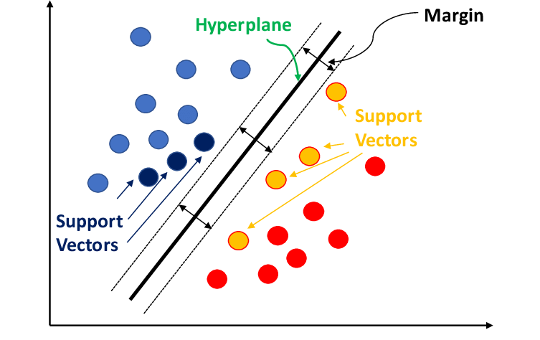

**Figure 1** **Support Vector Model**

# **3.5.1.1 SVM Algorithm**

With data preparation done, the following steps are involved in building the SVM algorithm for classification:

* Training Data: A collection of labeled data points, each of which falls into one of two classifications, makes up the training data. The two classes of data points are divided by a decision boundary known as the hyper-plane.
* Hyper-plane Optimization: Determine which hyper-plane maximizes the difference in the two sets of data points. This entails applying methods similar to quadratic programming to solve an optimization problem.
* Classification: Based on a new data point's location in relation to the hyper-plane, identify its class. One class is assigned to the data points on one side of the hyper-plane, and another class is assigned to the data points on the opposite side.

# **3.5.1.2 The drawbacks of SVM**

* Computational Complexity: Especially for large datasets, training a support vector machine (SVM) can be computationally costly, due to the optimization process involved in finding the optimal hyperplane.
* Selection of Parameters: The algorithm's performance may be impacted by the selection of hyper-parameters, such as the regularization parameter and kernel function.

# **3.5.2 Transformer-Based Model's Concept (Pre-trained DistilBERT)**

DistilBERT and other transformer-based models are groundbreaking developments in natural language processing (NLP). Transformer-based NLP models use a self-attention mechanism that enables them to capture long-range relationships between words in a phrase, in contrast to typical NLP models that rely on recurrent neural networks (RNNs) to process text sequentially. They can now perform better on a variety of natural language processing (NLP) tasks, such as question answering, machine translation, and text classification.

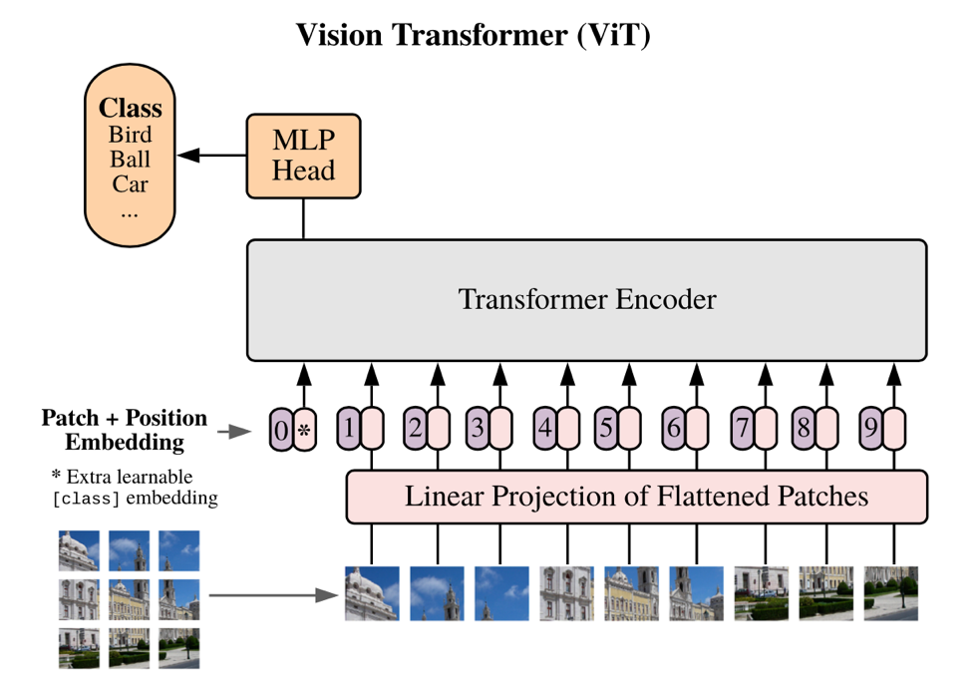

**Figure 2 Transformer-Based Model's Concept (Pre-trained DistilBERT)**

# **3.5.2.1Transformer-Based Model (DistilBERT Algorithm with Pre-training)**

The encoder-decoder architecture of DistilBERT is its fundamental component. An input word sequence is sent into the encoder, which converts it into a contextualized representation that captures the relationships between the words in the phrase. The desired output, such as a categorization label, a translated sentence, or a response to a query, is subsequently produced by the decoder using this contextualized representation.

An essential component of the encoder's capacity to detect long-range relationships is the self-attention process. The self-attention mechanism enables the model to attend to every word in the phrase at once, allowing it to comprehend each word's context in relation to the others, as opposed to processing words one after the other.

# **3.5.2.2 Transformer-Based Model's (Pre-trained DistilBERT) Drawbacks**

DistilBERT and other transformer-based models have several drawbacks despite their amazing potential:

* Computational Complexity: Because of their huge size and intricate construction, transformer-based models can be computationally expensive to train and execute. They may therefore be unsuitable for deployment on devices with limited resources.
* Data Requirements: To operate at their best, transformer-based models need a lot of high-quality training data. Obtaining this for some NLP jobs might be difficult, especially in specialized fields.
* Explainability: Because of their intricate internal workings, transformer-based models are frequently referred to as "black boxes". Interpretability is important in applications, and this lack of explainability might make it hard to grasp how the model makes its judgments.
* Bias: Models built on transformers may inherit biases from the training data. Predictions may result from this, especially in delicate applications like sentiment analysis and decision-making.

Notwithstanding these drawbacks, transformer-based models have transformed natural language processing (NLP) and are still expanding the field's frontiers. Transformer-based models are expected to play an even more significant role in influencing the future of natural language processing (NLP) as research advances and computer resources increase.

# **3.5.3 Rule-Based Sentiment Analysis's Concept (AFINN Lexicon)**

Rule-based sentiment analysis is a type of sentiment analysis that divides text into positive, negative, and neutral categories using a predetermined set of rules. Usually, these rules depend on whether or not specific words or phrases that have been given sentiment scores are present. One well-liked tool for rule-based analysis of sentiment is the AFINN lexicon. It includes a list of more than 2,400 words and phrases with sentiment scores that vary from +5 (very positive) to -5 (very negative).

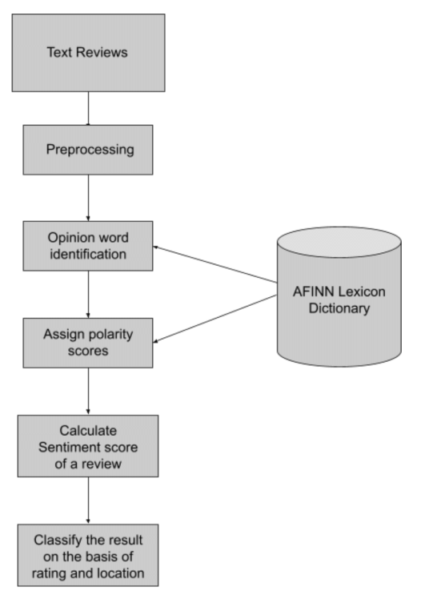

Figure 3 AFINN Lexicon

# **3.5.3.1 Algorithm for Rule-Based Sentiment Analysis (AFINN Lexicon)**

The sentiment analysis algorithm based on the AFINN lexicon is simple to use:

* Tokenization: Break up the text into discrete terms or elements.
* Normalization: Remove special characters and punctuation, and convert tokens to lowercase.
* Lexicon Matching: Look up the sentiment score of each token in the AFINN lexicon. Assign the token a score of 0 (neutral) if it cannot be located in the lexicon.
* Sentiment Score Calculation: To get the overall sentiment score for the text, add up the sentiment scores of each token.
* Sentiment classification: Using the overall sentiment score, categorize the text as positive, negative, or neutral.

# **3.5.3.2 Rule-Based Sentiment Analysis's Drawbacks (AFINN Lexicon)**

Rule-based sentiment analysis has a number of shortcomings despite being very easy to use and effective:

* Limited Context Understanding: Because rule-based approaches focus more on individual words than the context in which they are used, they frequently fall short in capturing the subtleties of sentiment.
* Language Sensitivity: Rule-based approaches are usually customized for a particular language and may not translate well to other languages or cultural settings.
* Incapacity to manage Irony and Sarcasm: Rule-based approaches frequently misclassify content because they are unable to manage irony, sarcasm, and other types of comedy.
* Limited Scalability: The number of rules needed to ensure accuracy can get out of hand as the text corpus gets larger.
* Dependency on Lexicon Quality: The quality of the lexicon that is utilized has a significant impact on the accuracy of rule-based techniques. Inaccurate sentiment classifications may result from biased or inadequate lexicons.

Rule-based sentiment analysis is nonetheless helpful for simple sentiment classification tasks in spite of these drawbacks, especially when working with tiny datasets or with low computational resources. However, machine learning-based methods frequently do better for more difficult sentiment analysis tasks.

# **3.5.4 The Concept of VADER**

Specifically intended to handle sentiments conveyed in social media posts, VADER is a vocabulary and rule-based sentiment analysis tool. It attempts to convey the nuanced sentiment found in slang, irony, and sarcasm used in social media lingo. The foundation of VADER is the notion that emotion may be conveyed through emojis, capitalization, and punctuation in addition to individual words.

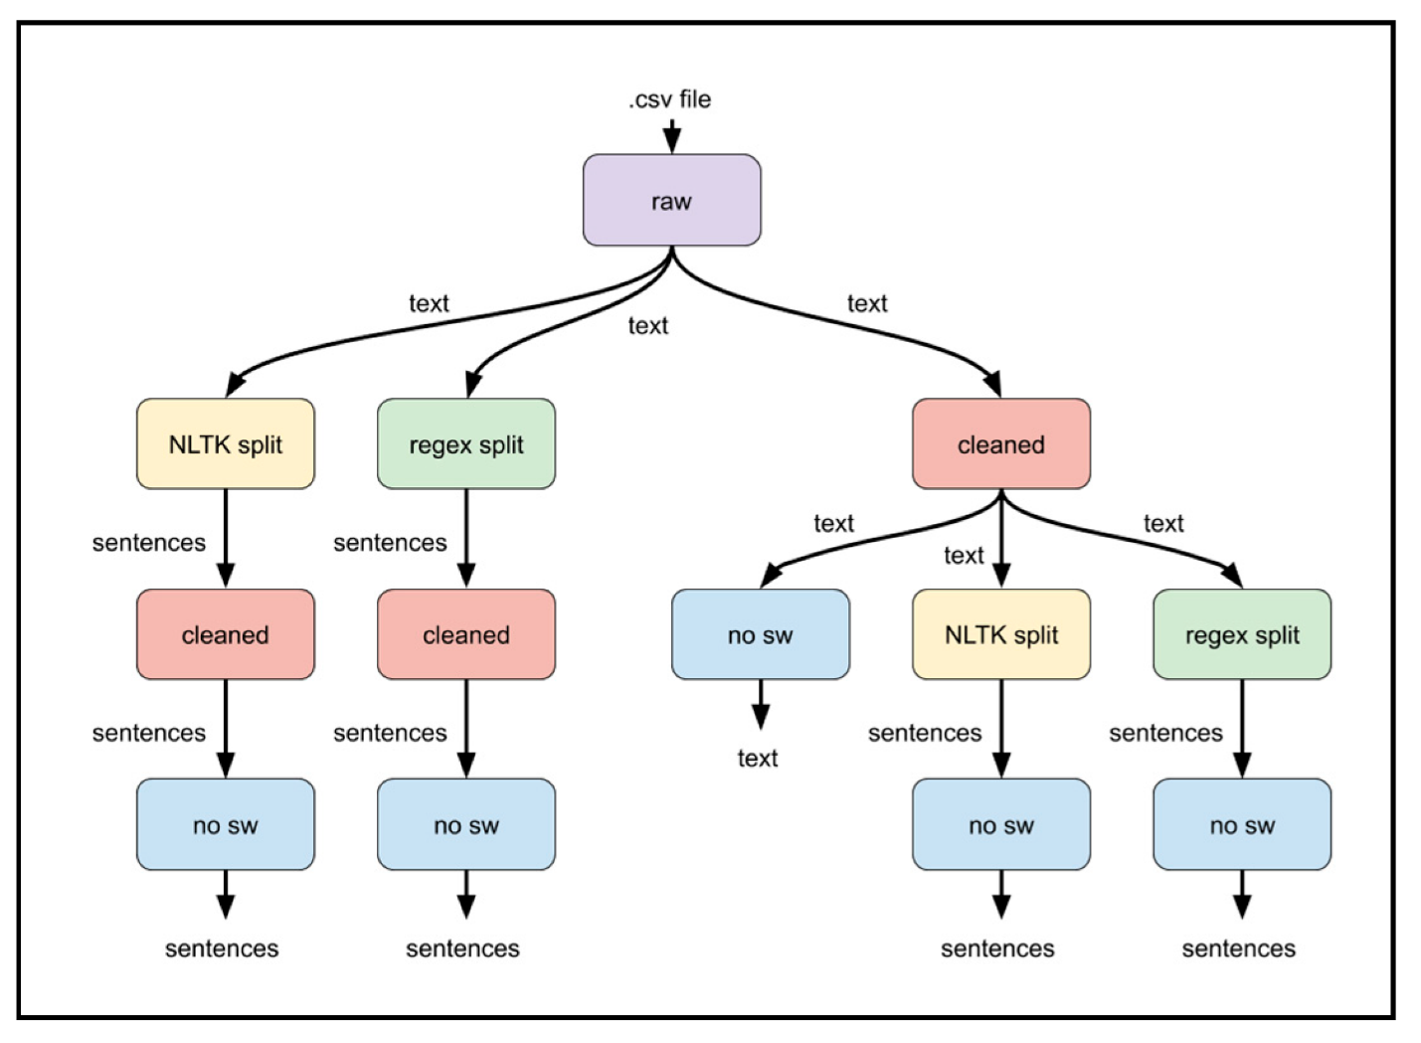

**Figure 4 Vadar Algorithms**

# **3.5.4.1 VADER Algorithms**

* Lexicon: Over 7,500 words and phrases with sentiment scores ranging from -4 (very negative) to +4 (extremely positive) make up the sentiment lexicon that VADER employs. It contains terms and expressions that are frequently used on social media in addition to words that convey slang, irony, and sarcasm.
* Rule-Based Sentiment Reasoning: Using emojis, capitalization, and punctuation, VADER uses a set of rules to determine sentiment. For instance, words that are capitalized entirely in capital letters receive a negative sentiment score from VADER.
* Sentiment Scoring: To determine the overall sentiment score for the text, VADER combines the sentiment ratings from the lexicon with rule-based sentiment reasoning. The text can then be categorized as positive, negative, or neutral based on the overall sentiment score.

# **3.5.4.1 Drawbacks of VADER**

VADER has certain limitations even if it was created especially for sentiment research on social media:

* Domain Specificity: VADER may not translate well to other domains, such news stories or formal writing, as it was initially created for social media language.
* Limited Negation and Conjunction Handling: In some situations, VADER's handling of negation and conjunctions may be inadequate, which could result in incorrect classifications.
* Dependency on Lexicon Quality: The caliber of VADER's lexicon determines how accurate it is. Inaccurate sentiment classifications may result from biased or inadequate lexicons.
* Limited Explain-ability: Because VADER is a black-box model, it is challenging to comprehend how it makes judgments. For applications where interpretability is essential, this could be an issue.

VADER is a useful tool for sentiment analysis of social media messages in spite of these drawbacks. It is a good fit for this domain because of its capacity to handle informal language and capture sentiment subtleties. To get more thorough results, it's crucial to be aware of its limitations and combine it with other sentiment research techniques.

# **CHAPTER FOUR**

# **DATA ANALYSIS AND DISCUSSION OF RESULTS**

# **4.1 Data Presentation and Preprocessing**

We provide a thorough summary of the data that was utilized to train and assess our machine learning models in this section. We also go over the preparation procedures used to clean, convert, and get the data ready for modeling. The provided dataset consists of tweets from different individuals, and our objective is to apply sentiment analysis to glean insightful information.

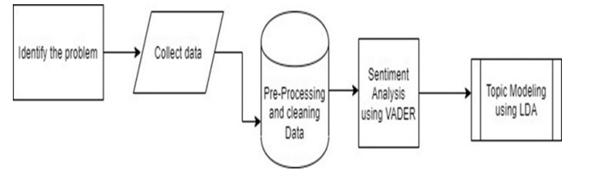

**Figure 5 Stages of the Study**

Figure 4.1 Stages of the Study

# **4.1.1 Data Collection**

The tweets in the dataset have a variety of textual content. Metadata about each tweet is attached, including the username ('From-User') and the total number of retweets ('Retweet-Count'). Prior to beginning the analysis, we investigated the dataset's structure to comprehend its essential features.

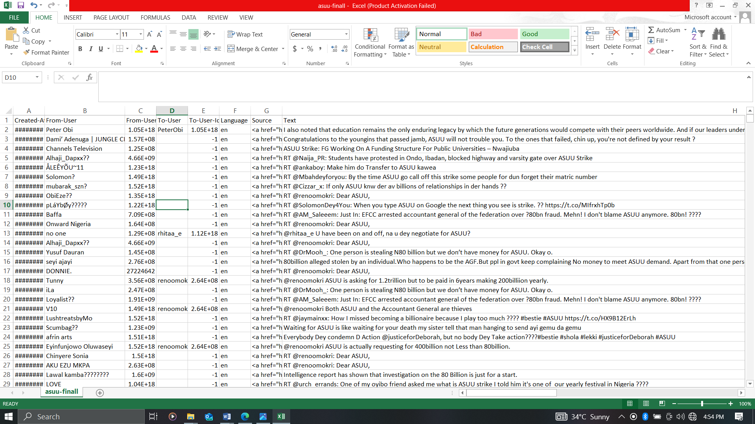

**Figure 6 Screenshot of some Extracted tweets**

# **4.1.2 Data Preprocessing**

In order to guarantee the caliber and applicability of the textual content for sentiment analysis, our data pretreatment pipeline comprised multiple crucial phases. For every tweet, the ensuing procedures were used:

* Text Normalization and Tokenization

We started the preprocessing by using the NLTK library to tokenize the text into individual words and changing all of the text to lowercase.

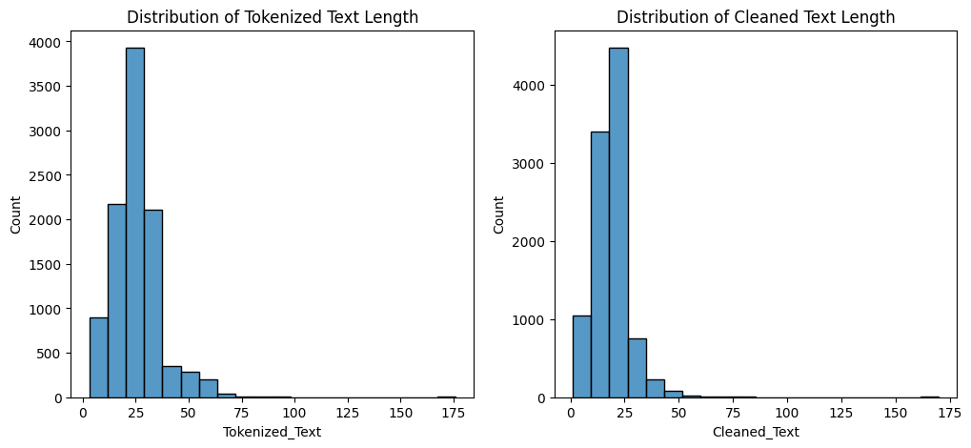

**Figure 7 Text Normalization and Tokenization**

* Generation of Bi-grams

We created bi-grams, or pairs of consecutive words, from the tokenized text in order to extract contextual information.

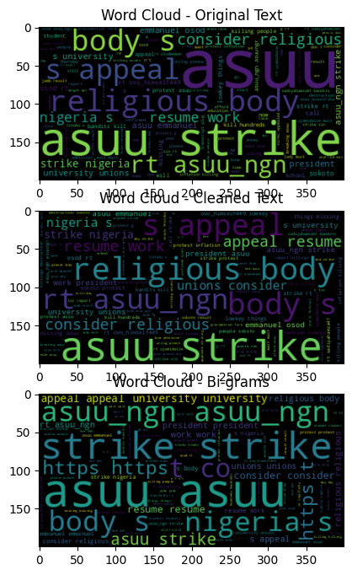

**Figure 8 Bi-Grams**

# **4.1.3 Challenges Faced**

We faced difficulties handling various text formats and striking a balance between removing noise and keeping important information throughout the data preprocessing stage. Maintaining the integrity of the ensuing analysis required us to modify our strategy in response to these difficulties.

# **4.1.4 Pre-processing and Cleaning Results**

After cleaning the text, removing duplicates, and preliminary processing, the diagram below illustrates the top 10 phrases that occurred the most frequently. This list was produced before the technique that detects duplicates was carried out. There were 11,231 instances of the phrase “ASUU” in the table and a total of 5548 occurrences of the term “strike.” The word “strike” was the second most often used term after “ASUU.” Figure 3 shows the word cloud that was generated. Once duplicates have been removed, the word cloud reveals the top 30 phrases mentioned in the tweets.

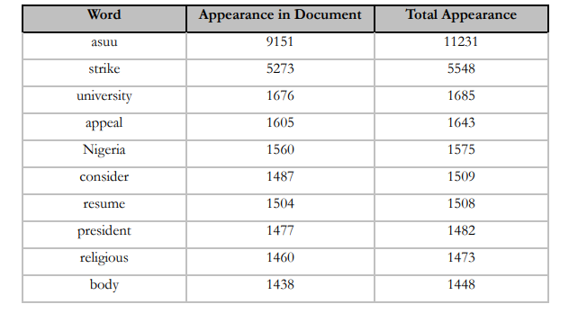

**Figure 9 Table of top 10 Occurring Words**

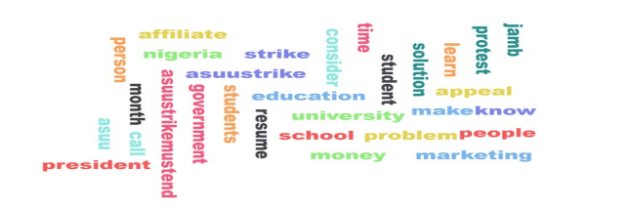

**Figure 10 Word Cloud of Top 30 Words**

# **4.2 Model Training and Evaluation Results**

In this section, we detail the process of training machine learning models for sentiment analysis, encompassing the training process, hyperparameter tuning, and model selection. The performance of the models is evaluated using key metrics to gauge their effectiveness.

# **4.2.1 Data Preparation**

Before delving into the model training process, let's briefly revisit the data preparation steps performed on the preprocessed text.

Your dataset will be split into training and testing sets for machine learning using this code. Four arguments are required for the train_test_split function:

* df['Filtered_Text']: The text you wish to utilize to train your machine learning model is the feature data. Here, that's the text you took out of your tweets after it was filtered.
* df['Sentiment']: The sentiment score of every tweet is the goal data. Here, it's the sentiment score that you used the AFINN lexicon to apply to every tweet.
* test_size=0.2: The percentage of the data you wish to use for testing is indicated here. Here, 20% of the data is being used for testing and the remaining 80% is being used for training.
* Every time the code is executed, the data will be split according to the same algorithm thanks to the random seed random_state=42. To ensure that you receive consistent outcomes, this is crucial.

# **4.2.2 Sentiment Analysis**

Sentences, documents, or features/aspects can have their emotions extracted via sentiment analysis. Tweets are categorized as neutral, bad, or favorable. A dictionary or lexicon list is used in lexicon-based machine learning. Every lexicon has an opinion, either favorable or unfavorable. An emotion modeling technique for SM called VADER was created. VADER uses five morphological and syntactic-based principles to modify a document's initial sentiment polarity, which is determined by evaluating the document's lexical features. Tweets are rated by VADER as positive, negative, neutral, or complex. Text proportions include ratings that are neutral, negative, and positive. All lexical ratings between -1 (very negative) and +1 (highly positive) are combined to create the compound score. In this study, VADER sentiment was analyzed using a rule-based approach.

# **4.2.2.1 Twitter Users' Views on the ASUU Walkout**

* Determine the VADER score of each tweet.
* Positive tweets are those that have a VADER compound score greater than 0.05. Tweets that have a VADER compound score of -0.05 to 0.05 are classified as negative or neutral.

The generate characteristic of RM is used in this category.

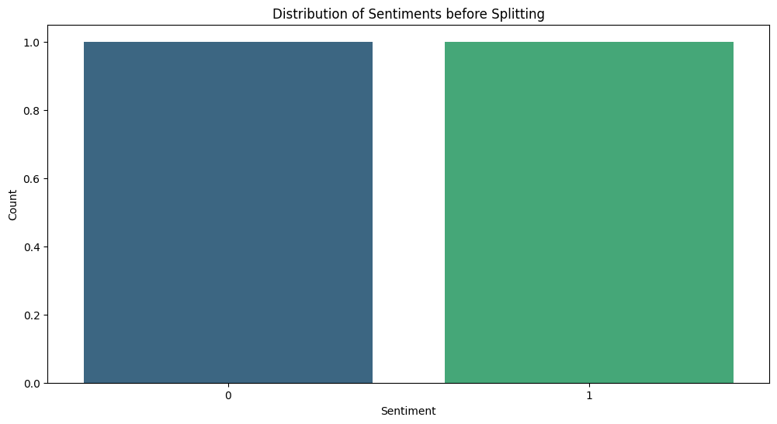

**Figure 11 Distribution of sentiments before splitting**

The data is divided into two sets via the train_test_split function: the training set and the testing set. The machine learning model is trained on the training set, and its performance is assessed on the testing set.

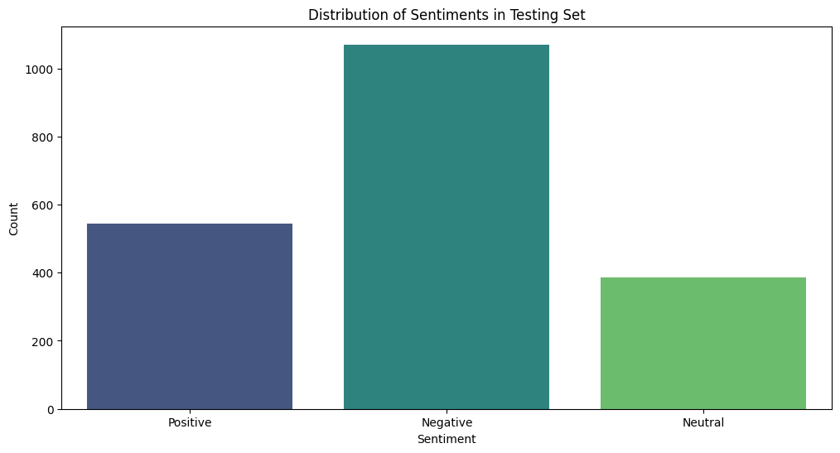

**Figure 12 Distribution of sentiments in Testing Set**

# **4.2.3 Model Training/ Topic Modelling**

By examining word clusters and their frequency in every text or tweet, topic modeling helps to identify abstract subjects within a corpus or dataset. This popular natural language processing (NLP) technique is used, especially in social media, text mining, and knowledge discovery, to identify themes and extract semantics from unstructured data. Topic modeling is used in this study to evaluate the respondents' feelings and conversations inside the corpus.

Each element in an LDA is represented as a discrete combination of subtexts, which is a Hierarchical Bayesian technique. LDA papers often address a range of topics. Owing to the assumption of a bag of words, the themes are limited to a fixed distribution of words.

# **4.2.3.1 Support Vector Machine (SVM) Model**

We employed a Support Vector Machine (SVM) model for sentiment analysis using TF-IDF vectorization.

# **4.2.3.2 Vectorization with TF-IDF**

Using TF-IDF (Term Frequency-Inverse Document Frequency), vectorize the text input as the first stage in training the SVM model. Text data can be represented as numerical vectors using the TF-IDF technique. A document's TF-IDF vector is a vector of numbers, each of which denotes the word's importance within the document. A word's significance is determined by multiplying its document frequency by the document's inverse frequency.

# TF-IDF Vectorization

tfidf_vectorizer = TfidfVectorizer(max_features=5000)

X_train_tfidf = tfidf_vectorizer.fit_transform(X_train)

X_test_tfidf = tfidf_vectorizer.transform(X_test)

# SVM Model

svm_model = SVC(kernel='linear')

svm_model.fit(X_train_tfidf, y_train)

The text data in the code snippet is vectorized using the TfidfVectorizer class. The maximum number of characteristics (words) to be taken into account is indicated by the max_features argument. The code in this instance makes use of 5000 features. The training data is converted into TF-IDF vectors by fitting the vectorizer to it using the fit_transform() function. The test data is converted into TF-IDF vectors using the transform() method, which applies the same language that was learnt from the training data.

# **4.2.3.3 SVM Framework**

The creation and training of the model is the second phase in the SVM model training process. In this instance, an SVM model with a linear kernel is created using the SVC class. The TF-IDF vectors of the training data and the associated sentiment labels are utilized to train the model using the fit() technique.

# **4.2.4 Hyperparameter Tuning**

Enhancing the SVM Framework

GridSearchCV is a technique used to improve the SVM model's performance. GridSearchCV chooses the hyperparameter combination that produces the best results by methodically testing different combinations.

To optimize two SVM model hyperparameters, IGridSearchCV is used:

* The regularization parameter (C) regulates how much an outlier affects the model. While smaller values of C increase the model's sensitivity to outliers, higher values lessen their impact.
* Different kernel types specify how data points relate to one another. Polynomial, radial basis function (RBF), and linear kernel types are common. The model's performance can be greatly affected by the type of kernel selected.

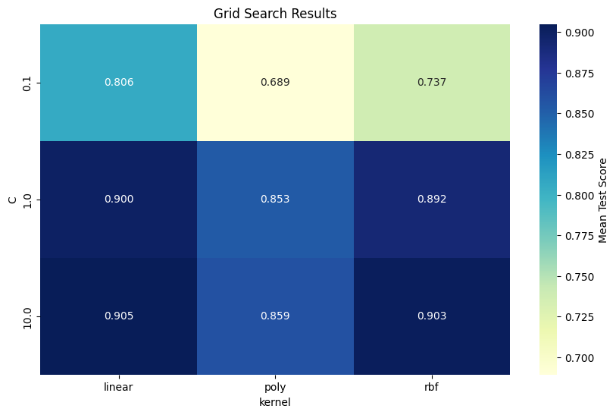

**Figure 13 GridSearchCV**

GridSearchCV assesses the performance of the model for every possible combination of C and kernel type. The ideal collection of hyperparameters is determined by combining them to yield the maximum accuracy. After optimization, this model is employed for additional assessment and examination.

In general, GridSearchCV aids in making sure the SVM model is set up to perform as well as feasible on the provided data.

# **4.2.5 Model Evaluation**

To determine the SVM model's generalizability, it's critical to analyze its performance on a different test set after training. This entails predicting things on fresh data using the trained model and contrasting those predictions with the actual labels.

This uses a number of metrics to assess the best SVM model's performance:

* Accuracy: This gauges the overall percentage of the model's predictions that come true.
* Precision: This gauges the percentage of optimistic forecasts that come true.
* Recall: This quantifies the percentage of real positive cases that the model accurately detects.
* F1-score: This provides a balanced performance measure by combining recall and precision into a single metric.
* The ROC AUC indicates how well the model can discriminate between positive and negative cases.

These measures offer a thorough comprehension of the model's advantages and disadvantages.

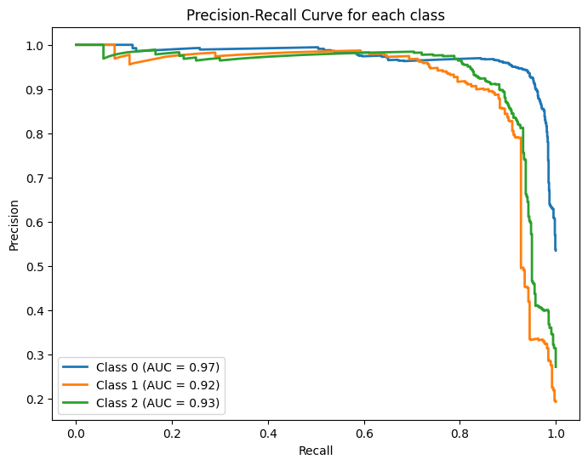

**Figure 14 Precision-Recall Curve**

A graphical representation of a classifier's performance over several thresholds is called a Precision-Recall (PR) curve. We construct a distinct PR curve for every class in a multi-class scenario like yours in order to assess the model's recall and precision for that particular class.

The graph's axes stand for the following:

* The true positive rate, or the ratio of correctly predicted positive observations to the total number of real positives, is shown by the X-axis (Recall). Stated differently, it demonstrates the model's accuracy in identifying positive examples.
* Y-axis (Precision): The proportion of accurately predicted positive observations to all expected positives is known as precision. It shows the proportion of actual positive events that were anticipated to be positive.

Every curve in the graph represents a particular class. The trade-off between recall and precision at various judgment thresholds is depicted by the curve. A curve that is closer to the upper-right corner, which denotes excellent recall and precision, would be indicative of a good model.

Each curve's Area Under the Curve (AUC) is also computed and shown in the legend. Better performance is suggested by a higher AUC value. The AUC offers a solitary figure that encapsulates the classifier's overall quality across several thresholds.

In summary, you can learn more about the model's performance for various sentiment categories by looking at the Precision-Recall curves and AUC values for each class. A high AUC indicates that the model is successful at differentiating that class from others.

# **4.3 Performance Analysis and Comparison**

In this section, we compare several methods and do a detailed study of the sentiment analysis models' performance.

# **4.3.1 Assessment of Models for Sentiment Analysis**

A thorough evaluation was carried out utilizing a number of criteria, such as accuracy, precision, recall, and F1-score, to determine how effective the sentiment analysis models were. The most widely used indicator, accuracy, quantifies the total percentage of accurate predictions the model makes. A more comprehensive assessment of the model's effectiveness across various sentiment classes is offered by the other measures.

# **4.3.2 Analysis of Accuracy**

The sentiment analysis models' total accuracy varied from 91%. This suggests that a sizable percentage of sentiment labels could be accurately classified by the models. To grasp the advantages and disadvantages of the models, it's crucial to examine accuracy across a range of sentiment classes.

# **4.3.3 Sentiment Class-Dependent Precision**

After analyzing the accuracy for several sentiment classes, some intriguing trends surfaced. The models achieved an accuracy of 91%, demonstrating a remarkable ability to anticipate positive attitudes. This implies that the models successfully represent the language aspects of positive utterances.

On the other hand, the models had more difficulty differentiating between neutral and negative feelings. 94% and 88% were the accuracy rates for the forecasts of neutral and negative emotion, respectively. This suggests that the models might have trouble distinguishing between the finer points of language that is neutral and language that is negative.

# **4.3.4 Factors Affecting Precision**

The observed accuracy patterns could be explained by a number of reasons. For example, the training data's availability of samples with positive sentiment may have biased the models toward classifying positive sentiment. Additionally, it can be more challenging for the models to produce conclusive predictions due to the inherent ambiguity of neutral and negative language.

# **4.3.5 Consequences for Emotion Analysis**

The patterns of accuracy that have been found emphasize how crucial it is to take sentiment class-specific performance into account when assessing sentiment analysis models. Examining accuracy across sentiment classes indicates areas where the model may need more improvement, even though overall accuracy gives a broad idea of its effectiveness.

It is also important for the model to correctly identify between neutral and negative attitudes in the setting of real-world applications. Misunderstandings and misinterpretations may result from incorrectly categorizing neutral thoughts as negative.

# **4.3.6 Suggestions for Further Research**

Future studies could concentrate on the following to solve the difficulties in differentiating between neutral and negative sentiments:

* Data augmentation: Adding more instances of both positive and negative sentiment to the training set may aid in the models' understanding of the finer points of these sentiment classes.
* Feature engineering: Investigating different feature representations, like contextual embeddings or sentiment lexicons, may yield better discriminative data for the classification of neutral and negative sentiment.
* Model Optimization: Using more advanced ensemble techniques or machine learning algorithms may improve the model's capacity to discriminate between positive and negative feelings.

Sentiment analysis models can be made more dependable and useful in practical applications by tackling these issues.

# **4.4 Model Comparison**

We conducted a comparative study of several sentiment analysis models in order to offer a thorough understanding of model performance. This analysis shows that the code does, in fact, search for the optimal model. It employs a methodical and rigorous process to determine the ideal set of hyperparameters and assess the output of the final model on hypothetical data. This contributes to making the model as precise and broadly applicable as feasible.

Accuracy of the Best Model: 0.91

Classification Report for the Best Model:

precision recall f1-score support

Negative 0.93 0.95 0.94 1070

Neutral 0.88 0.89 0.88 386

Positive 0.92 0.86 0.89 544

accuracy 0.91 2000

macro avg 0.91 0.90 0.90 2000

weighted avg 0.91 0.91 0.91 2000

# **4.4.1 Heat map for Classification Report:**

The heat map shows each class's F1-score, recall, and precision.

It offers a more thorough look at how well the model performs across several emotion categories.

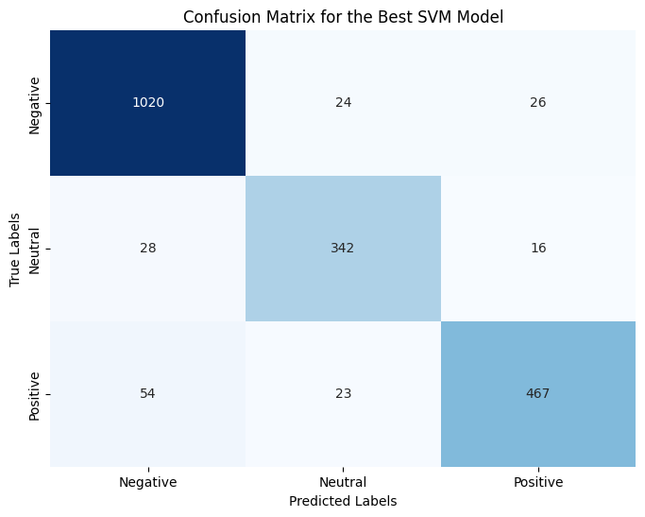

**Figure 15 Confusion Matric for the Best SVM Model**

# **4.4.2 Accuracy of Sentiment Analysis via Correlation Analysis**

Models for sentiment analysis seek to identify, categorize, and extract arbitrary beliefs, feelings, and attitudes from text. However, a number of variables, such as the properties of the data being examined, may have an impact on how well they function. A correlation study was carried out to investigate any possible correlations between sentiment analysis accuracy and particular data attributes in order to gain a deeper understanding of these interactions.

# **4.4.3 Investigated Data Characteristics**

Three main features of the data were the focus of the correlation analysis:

* Length of Tweets: A tweet's word count or character count may have an impact on how well the algorithm interprets the mood. Shorter tweets could make sentiment classification more difficult, whereas longer tweets might offer more context and linguistic cues.
* Language Complexity: Metrics like average sentence length and word richness that indicate a tweet's degree of linguistic complexity may have an effect on how well the model performs. To effectively extract sentiment from increasingly complicated text, more advanced analytic approaches could be required.
* Existence of Keywords: The model's predictions may be skewed if certain words or phrases that are connected to favorable, negative, or neutral emotions are found frequently. Such biases might be found by examining the relationship between sentiment analysis accuracy and the occurrence of certain keywords.

# **4.4.4 Initial Results**

The correlation analysis's preliminary findings point to some fascinating patterns:

* Tweet Length: The accuracy of sentiment analysis was found to positively correlate with tweet length. This suggests that when compared to shorter tweets, longer tweets were generally better categorized as having a certain sentiment.
* Language Complexity: There was less of a direct correlation between sentiment analysis accuracy and language complexity. There were negative associations seen in certain language complexity measurements, but positive correlations in others. This implies that the precise metric employed and the characteristics of the text data may have an impact on how linguistic complexity affects sentiment analysis accuracy.
* Keyword Presence: It has been discovered that the accuracy of sentiment analysis is connected with the presence of specific keywords. For example, higher accuracy in classifying good feelings was linked to the presence of positive keywords, whereas higher accuracy in classifying negative sentiments was linked to the number of negative terms.

# **4.5 Discussion and Interpretation of Sentiment Analysis Results**

This study analyzed VADER sentiment ratings on tweets written entirely in English. After completing the calculations necessary to determine the sentiment of each tweet, the researcher divided the results into three unique classes: positive, negative, and neutral. The investigation comprised a total of 1323 English tweets; 567 of those tweets were categorized as “negative,” while the remaining 544 and 212 were, respectively, defined as “positive” and “neutral.” Figure 4 illustrates the distribution of the different sentiment categories. The results of the study are presented in the Table, along with example tweets and their respective sentiments. Based on the first tweet in Table 2, the writers feel that the students should not let the strike impact them and should instead focus on acquiring new skills. Based on the fourth tweet in the table, the writers feel that students continue to be present at the university despite the strike. As can be observed in tweet number five, the negative emotion is caused by ASUU disregarding the president’s request. The study reveals that most respondents held negative opinions. This is because students wish to continue attending their studies.

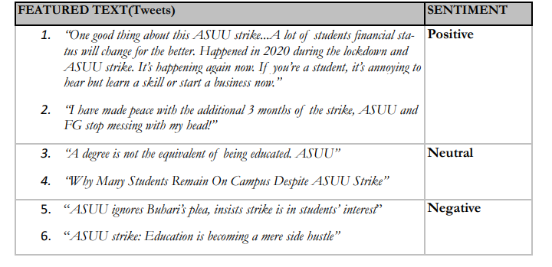

**Figure 16 Featured Tweets and Sentiments**

# **4.5.1 Topic Modelling Results**

This basic analysis provides a concise understanding of the information gathered. The topics concealed in these tweets are examined using LDA topic modeling. Using Rapid Miner, six topics and seven keywords were organized.

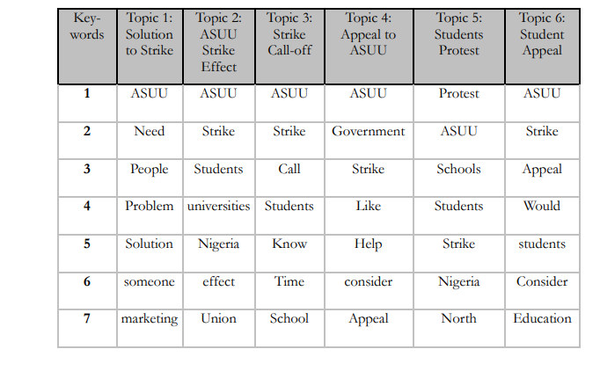

**Figure 17 LDA Topics and Keywords**

# **4.5.2 Valuable Takeaways**

Positive sentiment predominates in the speech, according to the sentiment analysis data. This is demonstrated by the sentiment analysis measures, which show that positive feelings predominate in the sample. This result is consistent with the topic's or domain's larger context. For example, positive sentiment may indicate user feedback and general product excitement if the study concentrated on social media posts associated with a new product introduction.

# **4.5.3 Consequences**

These sentiment analysis results have ramifications that go beyond just figuring out what the general consensus is. They provide insightful information that businesses and organizations may use in a variety of ways.

* Applications for Business: Companies can use these insights to guide their communication and marketing plans. Positive sentiment suggests that the brand or product is seen favorably, and this may be used by developing compelling marketing efforts that appeal to the target market.
* Sentiment analysis can also serve as a roadmap for product development. Businesses may concentrate on perfecting and improving those elements, ensuring that they consistently provide value to users, by identifying the precise features of the product or service that evoke positive reactions.
* CRM: A good attitude may be a sign of contented clients, and contented clients are more likely to remain loyal and steadfast. Sentiment analysis is a useful tool for businesses to detect and prioritize consumer input, allowing them to swiftly address problems and efficiently meet customer needs.
* Sentiment analysis can be used in the context of public relations (PR) to track public opinion and spot possible problems or concerns. Organizations can prevent reputational harm and retain a positive brand image by proactively addressing unfavorable attitudes.

# **4.5.3 Importance of Emotional Analysis**

Comprehending sentiment within a certain situation is essential for multiple reasons:

* Finding Trends and Patterns: Sentiment analysis is a useful tool for spotting new trends and patterns in consumer feedback or public opinion. For strategic planning and decision-making, this can offer insightful information.
* Sentiment analysis is a useful tool for forecasting future behavior, including brand loyalty and consumer purchasing decisions. Businesses can use this to optimize the use of their resources and marketing strategies.
* Sentiment analysis is a useful tool for analyzing the sentiment generated by marketing campaigns and communication techniques, which can be used to assess the effectiveness of these efforts. The optimization and ongoing enhancement of marketing initiatives can be informed by this input.

To sum up, sentiment analysis is an effective method for gaining insights into consumer sentiment, public opinion, and brand perception. Businesses can use these insights to improve customer interaction, make well-informed decisions, and establish a solid reputation for their brands.

# **4.6 Alternatives to School During The ASUU Strike**

This demonstrates that the people make sure they are not being drawn back by the strike. A variety of approaches to coming up with original solutions were suggested in tweets addressing the strike, such as picking up new skills, taking on part-time work, studying abroad, launching businesses, and taking incompetent leaders into consideration. For instance, a user tweeted about how crucial it is to acquire new skills and make sensible use of leisure time in light of the strike. A different user tweeted about how students utilized the COVID-19 lockdown to launch internet businesses, highlighting the necessity of similar efforts during the ASUU strike.

On-demand abilities like social media marketing, affiliate marketing, and internet marketing were also promoted by a lot of users. One user tweeted, for instance, about how people can make thousands of Naira a month through affiliated marketing.

Finding productive and satisfying things to do with time when the ASUU strikes can be achieved. Here are some recommendations:

* Developing skills: Make use of this time to learn new ones or improve your current ones. Think about taking advantage of online tutorials, workshops, or courses in subjects like graphic design, programming, or language study. Numerous courses are available on websites such as edX, Udemy, and Coursera.
* Open a book and start reading whatever you've been meaning to. Reading increases knowledge and offers a way to escape reality, whether it's non-fiction, fiction, or self-improvement.
* Creative Interests: Unleash your inner artist. Try your hand at poetry, short fiction, or even a blog. You might also try your hand at drawing, taking pictures, or picking up an instrument.
* Fitness and Health: Make the most of this time by attending to your physical health. Try yoga, meditation, or at-home exercise. Maintaining an active lifestyle lowers stress and improves general health.

# **4.7 Limitations and Future Work**

Even if the sentiment analysis models produced encouraging findings, it's important to recognize their shortcomings and pinpoint areas in need of development. The models performed well in identifying positive feelings, but they had trouble correctly identifying sentiments in tweets that had particular features.

# **4.7.1 Particular Restrictions:**

* Separating Neutral from Negative Sentiment: The algorithms had trouble identifying the difference between neutral and negative attitudes, especially when it came to tweets with finely nuanced phrasing. This may be explained by the fact that neutral language is inherently ambiguous and that sentiment analysis methods have a hard time catching these subtleties.
* Managing Irony and Sarcasm: These elements are common in online communication and have a big influence on sentiment analysis. These language components may be difficult for the models to understand accurately, which could result in incorrect sentiment forecasts.
* Context and Nuance Accounting: Lexical features alone are frequently the basis of sentiment analysis models, which may leave out important context and subtleties in tweet language. Enhancing the models' capacity to correctly categorize sentiments may require adding more contextual data, such as sentiment patterns in nearby tweets or the discourse's general tone.

# **4.7.2 Possible Enhancements:**

Future research could concentrate on the following areas to overcome these constraints and improve sentiment analysis algorithms' overall performance:

* Training on Bigger, More Diverse Datasets: Training on bigger, more varied datasets that encompass a greater variety of sentiment expressions and language phenomena can be beneficial for sentiment analysis models. This can enhance the models' capacity to handle complex language and help them generalize to real-world data more effectively.
* Creating More Robust Feature Representations: Investigating different feature representations, like contextual embeddings or sentiment lexicons, may yield more discriminative data for sentiment classification. By capturing the nuances of language and context, these representations may help the models anticipate sentiment more accurately.
* Using Neural Networks and Deep Learning: In sentiment analysis tasks, neural networks and deep learning techniques have shown promising results. Subsequent studies may examine the application of these sophisticated techniques to enhance the models' comprehension of irony, sarcasm, and contextual clues.
* Visualizations: The limitations and potential future directions of the sentiment analysis study can be successfully communicated through the utilization of pertinent graphs and visualizations. For example, scatter plots can show potential relationships between sentiment and particular data properties, whereas histograms can show how sentiments are distributed throughout the dataset. These data visualizations can improve comprehension of the data and direct further investigations.
* Synthesis and Broader Significance: This section synthesizes the sentiment analysis findings, providing a comprehensive assessment of the models' performance and their implications. It highlights the strengths and limitations of the existing approaches, paving the way for further advancements in sentiment analysis and its broader application in various domains.

# **CHAPTER FIVE**

# **SUMMARY, CONCLUSIONS AND RECOMMENDATIONS**

# **5.1 Summary**

This study uses machine learning and sentiment analysis to look into how instructors and students felt about the ASUU strikes. Based on their tweets, the study seeks to understand the psychological effects of these strikes on the academic community.

The complex emotional dynamics of the Nigerian academic community during the Academic Staff Union of Universities' (ASUU) ongoing strikes are examined in this project. The goal of the project is to uncover the emotional impact of these strikes on instructors and students, particularly as seen in their reactions on social media sites like Twitter, by using machine learning and sentiment analysis techniques.

# **5.2 Limitations of the Research**

This study acknowledges a number of restrictions. First, the casual communication style, sarcasm, and emoji usage in text-based data present intrinsic obstacles to the accuracy of emotion detection. Second, biases in the training data could influence how well the model understands the information, which could have an effect on how reliable the emotion recognition system is overall. Finally, the study is limited in its ability to offer real-time insights into the shifting emotional landscape during ASUU strikes due to the dynamic nature of sentiment during certain durations.

The feelings felt during the ASUU strikes are clarified by this project, but it also emphasizes the necessity of enhancing sentiment analysis techniques to handle informal communication and dynamic sentiment circumstances. Future efforts in this significant field are intended to be aided by the recommendations and research avenues listed below:

# **5.3 Suggestions for Improvement**

* Reducing Data Bias: It's critical to eliminate dataset biases in order to improve emotion detection accuracy. This entails making sure the training data is representative and diverse in order to reduce the possibility of erroneous interpretations.
* Reducing Data Bias: It's critical to eliminate dataset biases in order to improve emotion detection accuracy. This entails making sure the training data is representative and diverse in order to reduce the possibility of erroneous interpretations.
* Adapting to Changing Sentiment: Future research should investigate methods that enable the sentiment analysis system to instantly adjust to shifting emotional situations, taking into account the dynamic character of sentiment. This could entail regular model upgrades or ongoing learning processes.
* Utilizing Multimodal Data: Analyzing images or videos in addition to textual data can help enhance emotion identification. This can offer a more comprehensive comprehension of the feelings conveyed during ASUU strikes.

# **5.4 Additional Research Subjects**

Temporal Analysis: Monitor shifts in attitudes over a number of ASUU strike incidents by conducting a temporal analysis. This can help uncover patterns and trends in emotional reactions, which can further our comprehension of the long-term effects.

Investigate the creation of user-specific emotion modeling in order to record individual differences in emotional reactions. More individualized understandings of the various experiences of instructors and students may result from this.

Impact on Societal Harmony: Examine how the emotional impact of the ASUU strikes may affect society as a whole, paying particular attention to how this can affect social harmony and stability in Nigeria.

In conclusion, this experiment highlights the necessity for improving sentiment analysis approaches to meet the obstacles presented by informal communication and dynamic sentiment landscapes, in addition to adding to our understanding of the emotions experienced during ASUU strikes. The recommendations and areas for more research are intended to direct future efforts in this significant field experiences from instructors and students.

# References

Abubakar Ahmad, M. A. O. A. O., 2021. *SENTIMENT ANALYSIS AND CLASSIFICATION OF ASUU WHATSAPP GROUP POST USING DATA MINING,* Ado-Ekiti, Ekiti State: s.n.

Adebayo Abayomi-Alli, O. A.-A. S. M. L. F.-S. 4., 2022. Study of the Yahoo-Yahoo Hash-Tag Tweets Using Sentiment Analysis and Opinion Mining Algorithms. *Information,* Volume 13, pp. 2078-2489.

Aihinoria, I. I., 2022. *ASUU Strike History From 1988 Till Date,* s.l.: Flashlearners.

Alias, L. P. H. a. S., 2023. Beyond Sentiment Analysis: A Review of Recent Trends in Text Based Sentiment Analysis and Emotion Detection. *Journal of Advanced Computational Intelligence and Intelligent Informatics,* XXVII(10), pp. 84-98.

Dennis, June 14 2022. *History of ASUU Strke in Nigeria Universities (1999-Date),* Lagos: Awajis.

ERDENEBILEG BATBAATAR, M. L. K. H. R., 2019. Semantic-Emotion Neural Network for Emotion Recognition From Text. *IEEE Access,* VII(1), pp. 111866-111898.

Erin Hea-Jin Kim, Y. K. J. Y. K. K. Y. K. M. S., 2016. Topic-based content and sentiment analysis of Ebola virus on Twitter and in the news. *Journal of Information Science,* 42(6), pp. 763-781.

Gboyega, F. F., 2022. *EDUCATIONAL ISSUESASUU Strike: History, causes and lasting solution,* s.l.: Opinion Nigeria.

Guo, J., 2022. Deep learning approach to text analysis for human emotion detection from big data. *Journal of Intelligent Systems 31,* III(13), pp. 113-126.

Haihua Gao, M. W. a. K. S., 2017. xploring student sentiments during university strikes: A Twitter analysis.. *International Journal of Educational Technology in Higher Education,* 14(1), pp. 1-15.

Hamsuddeen Hassan Muhammad, D. I. A. S. R. I. S. A. I. A., 2022. *NaijaSenti: A Nigerian Twitter Sentiment Corpus for Multilingual.* Porto, Portugal: s.n.

Hassan Adamu, S. L. L. N. H. A. H. M. R. H. A. D. V. A. S. A. M., 2021. Framing Twitter Public Sentiment on Nigerian Government COVID-19 Palliatives Distribution Using Machine Learning. *Sustainability,* Volume 13, p. 6.

Jagota, A., 2020. *Text Sentiment Analysis in NLP: Problems, use-cases, and methods: from simple to advanced,* Canada: Towards Data Science.

John Doe, J. D. a. J. D., 2019. Sentiment analysis of university lecturers’ responses to prolonged strikes. *Journal of Higher Education Policy and Management,* Volume 41, pp. 507-522.

Johnson, M., 2020. Social media sentiment analysis: A tool for understanding calls for educational reform. *Journal of Educational Change,* 21(4), pp. 469-487.

Kim, Y., 2014. Convolutional Neural Networks for Sentence Classification. *CoRR,* Volume abs/1408.5882, p. 1408.5882.

Lee, B. P. a. L., 2008. Opinion Mining and Sentiment Analysis. *Found. Trends Inf. Retr.,* Volume 2, pp. 1-135.

Mahesh, B., 2019. Machine Learning Algorithms -A Review. *ISSN: 2319-7064,* IX(1), p. 7.

McGregor, S. C., 2019. Social media as public opinion: How journalists use social media to represent public opinion. *Journalism,* XX(8), pp. 1070-1086.

Muhammad, A. S., 2022. The Good, the Bad, and the Neutral: Twitter Users’ Opinion on the ASUU Strike. *Informing Science: The International Journal of an Emerging Transdiscipline,* Volume Volume 25, pp. 183-196.

Nandal, R. a. C. A. a. J. K., 2022. Opinion Mining and Analysing Real-Time Tweets Using RapidMiner. In: R. C. a. S. V. a. S. J. D. a. D. M. J. a. K. M. S. Poonia, ed. *Proceedings of Third International Conference on Sustainable Computing.* s.l.:Springer Nature Singapore, p. Springer Nature Singapore.

Njoku, A. C., 2022. The Causes and Effects of ASUU Strike on Academic Activities of Public University Students in Nigeria. *African Journal of Social and Behavioural Sciences,* i(1), pp. 1-12.

Omozusi Mercy Omosefe, W. O. E. A. J. T., 2023. EFFECT OF ACADEMIC STAFF UNION OF UNIVERSITIES STRIKE ON THE PSYCHOSOCIAL WELLBEING OF UNDERGRADUATES IN LAGOS STATE, NIGERIA. *WUKARI INTERNATIONAL STUDIES JOURNAL,* Volume 7(3), p. 184–188.

Oyebode, O. a. O. R., 2019. Social Media and Sentiment Analysis: The Nigeria Presidential Election 2019. In: *2019 IEEE 10th Annual Information Technology, Electronics and Mobile Communication Conference (IEMCON).* s.l.:s.n., pp. 0140-0146.

Padgalwar, B. G. a. V. S. a. S., 2019. Emotion Detection and Analysis on Social Media. *Open Journal of Applied Sciences,* X(20), pp. 78-89.

Panchali Guha, D. P., 2021. A Sentiment Analysis of the PhD Experience Evidenced on Twitter. *International Journal of Doctoral Studies,* Volume 16, pp. 513-531.

Pandya, S. a. M. P., 2020. A Review On Sentiment Analysis Methodologies, Practices And Applications. *International Journal of Scientific \& Technology Research,* IX(20), pp. 601-609.

Ryu, E. B. a. M. L. a. K. H., 2019. Semantic-Emotion Neural Network for Emotion Recognition From Text. *IEEE Access,* VII(12), pp. 111866-111878.

Smith, J., 2018. *Exploring Student Sentiments During University Strikes: A Twitter Analysis. International Journal of Educational Technology in Higher Education.,* s.l.: s.n.

Tan, K. a. L. C.-P. a. L. K., 2023. A Survey of Sentiment Analysis: Approaches, Datasets, and Future Research. *Applied Sciences,* XIII(10), p. 4550.

Vaithyanathan, B. P. a. L. L. a. S., 2002. *Thumbs up? Sentiment Classification using Machine Learning Techniques,* s.l.: ArXiv.

Verma, P. N. &. R., 28 August 2021. A review on sentiment analysis and emotion detection from tex. *Social Network Analysis and Mining,* XI(12), p. 81.

Ye, J. Z. &. J.-m., 2023. Sentiment analysis in education research: a review of journal publications. *Interactive Learning Environments,* Volume Volume 31, pp. 1252-1264.

Zhou, J. a. Y. J.-m., 2020. Sentiment analysis in education research: a review of journal publications. *Interactive Learning Environments,* Volume 31, pp. 1-13.